
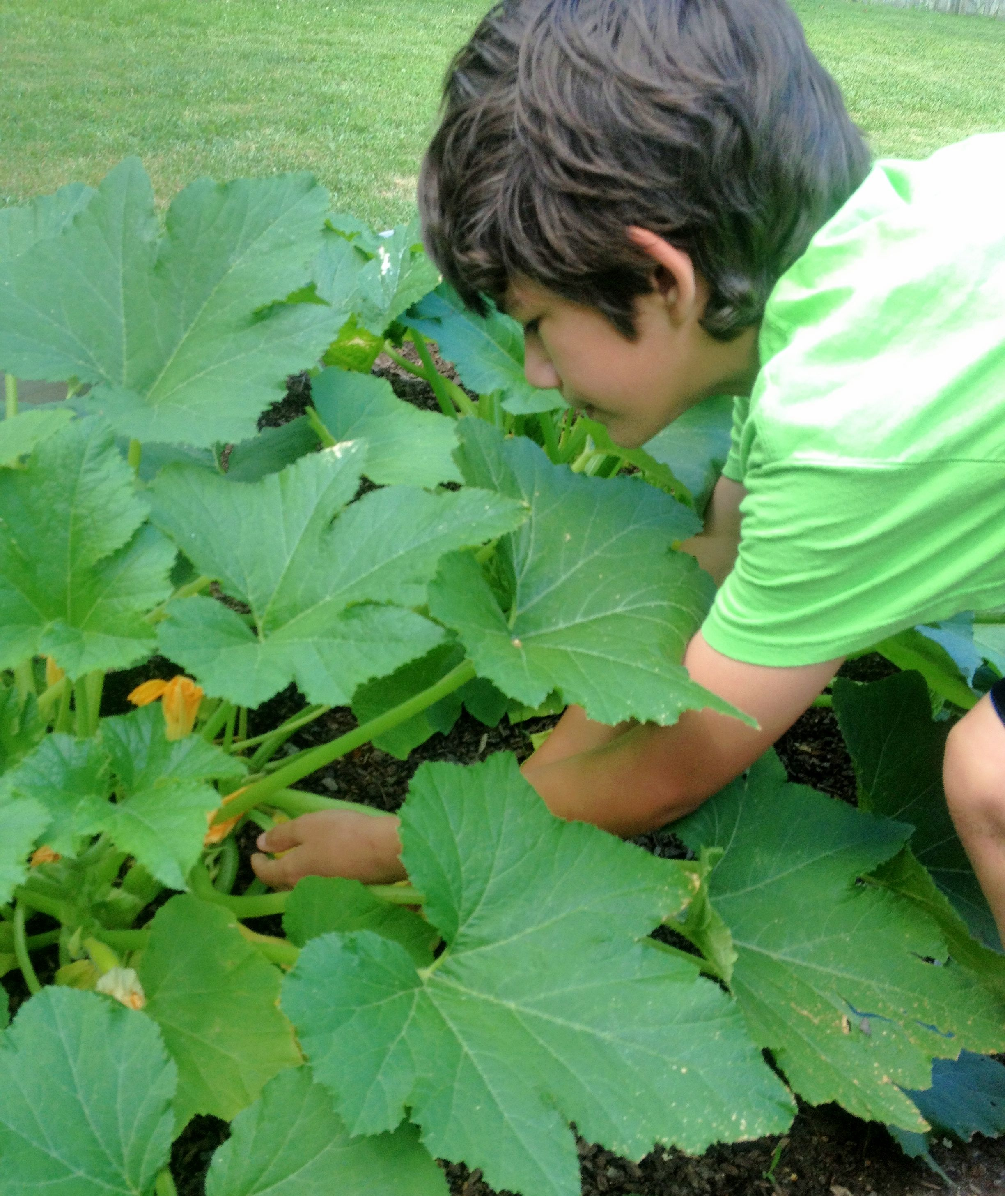
4-H Mini-Gardening Project

Enjoy plants and gardening? If you do, then it’s time to sign up for the 4-H Mini-Gardening Project. All county youth, ages 9-18, as of January 1, 2018, are eligible to participate.

In this project, youth will plant a 10-foot x 12-foot vegetable garden at home and maintain a garden journal. 4-H will provide all the seeds and plants for the garden. Each child will plant the same vegetables. SORRY – one child per garden – no team participation.

The program begins with an orientation session on Monday, May 7, 6:00 p.m., at the Cooperative Extension office in Jackson Park. At this session, you will receive seeds and plants and will learn how to prepare and plant your garden. Your parents and/or an adult helper should plan to attend the workshop with you. Please bring written directions to your house, from Jackson Park, when you come to the orientation. You must pre-register before coming to Orientation. Also, bring your calendar for the summer, so we can plan garden visits.

Mini-garden volunteers will visit each child’s garden at least twice during the summer to give pointers and review the garden journals. Judging dates for mini-gardens will be in June and July. As young people harvest their vegetables, they are encouraged to donate some to a food bank, can or freeze some of their vegetables, and enter canned goods and fresh vegetables in the N.C. Mountain State Fair. The Fair also offers several decorated fruit and vegetable classes that mini-gardeners may want to enter.

Youth will submit their journal for judging by Tuesday, August 7. The garden journal and the overall care of the garden throughout the project are used to determine winners. Cash prizes will be awarded. Winners will be announced at the 4-H Mini-Gardening Awards Program/Pot Luck Dinner on Monday, August 13, 6:00 p.m. Each child brings a dish for the dinner using vegetables from his or her garden. Twenty spaces are allotted for this project, and these spaces will fill on a first-come, first served basis. NO TELEPHONE RESERVATIONS ARE ACCEPTED. You may mail, email, or fax your registration form.

Note: This program is only available to Henderson County residents. Former Mini-Garden participants may repeat this program, if there is room. Newcomers’ names will be added to the list first.

If you are a person with a disability and desire any assistive devices or other accommodations to participate in this activity, please contact Denise Sherrill, Extension 4-H Agent, at 828-697-4891 during business hours of 8:30 a.m. and 5 p.m. to discuss accommodations at least 3 days prior to the event.

For more information about 4-H visit henderson.ces.ncsu.edu/4-H

REGISTRATION FORM

Name of Child ________________________________ 4-H Age (as of January 1, 2018) ____Circle: Male Female

School Date of Birth __________________ Grade in School _____________

Parent/Guardian Name ________________________________________________________________________

Mailing Address ____________________________________________________________________________

City ___________________________________________ State _______________ Zip Code ________________

E-Mail Address ______________________________________________________________________________

Home Phone Number ___________________________ Work Phone Number __________________________

Emergency Number ____________________________ Contact ____________________________________

My son/daughter has permission to participate in the 4-H activities checked below. In case of a medical emergency, I understand that every effort will be made to contact me. In the event I cannot be reached, I hereby give permission to the physician selected by Extension personnel to hospitalize, secure proper treatment for, and to order injection, anesthesia, or surgery for my child as named above.

Is your child allergic to any food or medicines? If yes, please describe. ________________________________
___________________________________________________________________________________________

Does your child have any special needs the staff should be aware of? If yes, please describe. ________________

___________________________________________________________________________________________

I authorize Cooperative Extension to use my child's image in newspaper articles, brochures, newsletters, web sites, and any other marketing efforts to promote the 4-H Youth Development Program:

Parent/Guardian Signature ______________________________________ Date _________________________

Registration for 4-H Mini-Gardening: You must pre-register before coming to Orientation.

Workshop Ages Registration Workshop Dates Fee Fee
Deadline Enclosed
____________________________________________________________________________________________
____ Mini- Monday
Gardening 9-18 May 4 May 7, 6:00 pm 0 XXXXX
(Orientation Session)
Twenty (20) spaces are offered for the Mini-Gardening Project and will fill on a first-come, first-served basis. If you want to participate, please submit a completed registration form as soon as possible. No phone reservations will be accepted. Forms may be emailed to Denise_Sherrill@ncsu.edu or faxed to 697-4581.
Please stop by the NC Cooperative Extension, Henderson County Center, in Jackson Park, to pick up a soil test kit for your garden, so you can send it in as soon as possible.

Return completed form to: Henderson County 4-H
100 Jackson Park Road
Hendersonville, N. C. 28792

North Carolina State University and North Carolina A&T University commit themselves to positive action to secure equal opportunity regardless of race, color, creed, national origin, religion, sex, age, veteran status or disability. In addition, the two Universities welcome all persons without regard to sexual orientation. North Carolina State University, North Carolina A&T University, U.S. Department of Agriculture, and local governments cooperating.

