Henderson County 4-H

*North River Farms Tour*

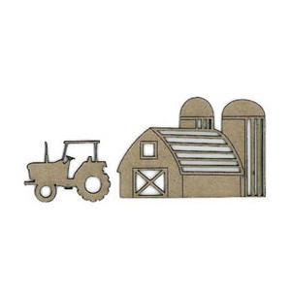

Saturday, Aug. 8: 10 am – 1 pm

*3333 N. Mills River Rd., Mills River, NC 28759*

For children ages 5 – 8, and their parents

Take a guided tour of a real working farm! Learn about daily operations, including planting and harvesting. After the tour, enjoy a picnic by the river!

Deadline to register: Aug. 5. Adult supervision required. Please bring a bag lunch & drink for each person in your family. Wear closed-toed shoes for the tour. Bring old shoes to wade in the river. We will meet at the farm at 9:45 am. Rain date: Sat., Sept. 19





*For office use only: 4-H age (as of January 1, 2015) ______*

**NORTH RIVER FARMS Tour**

Name of Child _______________________________ Age_______ Birth date ____/____/____

School __________________________________________ Grade in School______________

Parent/ Guardian Name___________________________________________________________

Mailing Address ________________________________________________________________

City ___________________________________ State ____________ Zip Code _____________

Email address _________________________________________________________________

Home Phone Number ______________________Work Phone #_________________________

Emergency Number ____________________ Contact: ________________________________

My son/daughter has permission to participate in the 4-H activities checked below. In case of a medical emergency, I understand that every effort will be made to contact me. In the event I cannot be reached, I hereby give permission to the physician selected by Extension personnel to hospitalize, secure proper treatment for, and to order injection, anesthesia, or surgery for my child as named above.

Is your child allergic to any food or medicines? If yes, please describe:

Does your child have any special needs the staff should be aware of? If yes, please describe:

I authorize Cooperative Extension to use my child's image in newspaper articles, brochures, newsletters, web sites, and any other marketing efforts to promote the 4-H Youth Development Program:

Parent/Guardian Signature __________________________________ Date _______________

Deadline to register: Wed., August 5

Rain date: Sat., Sept. 19

**Return registration form to: Henderson County 4-H, 100 Jackson Park Road, Hendersonville, N. C. 28792 (in Jackson Park, across from the ball fields). For more information, call the 4-H Office at 697-4891.**

If you are a person with a disability and desire any assistive devices or other accommodations to participate in this activity, please contact Sue Janowiak, 4-H Program Assistant, at 828-697-4891 during business hours of 8:30 a.m. - 5:00 pm (Monday-Friday) to discuss accommodations at least 3 days prior to the event.